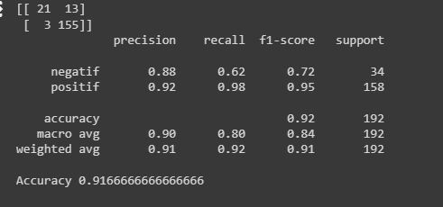

Classification Report:

Precision: Precision measures the accuracy of the positive predictions made by the model. For class negatif, it is 0.88, and for class positif, it is 0.92.

Recall: Recall measures the ability of the model to correctly identify positive instances. For class negatif, it is 0.62, and for class positif, it is 0.98.

F1-score: The F1-score is the harmonic mean of precision and recall. It provides a balance between precision and recall. For class negatif, it is 0.72, and for class positif, it is 0.95.

Support: The number of actual occurrences of the class in the specified dataset.

Accuracy: 0.917 - This is the proportion of correctly classified samples (both positive and negative) out of the total number of samples.

Interpretation:

The model seems to perform well overall, with an accuracy of 91.7%.

It shows high precision and recall for both classes, indicating that the model makes accurate positive and negative predictions.

However, the recall for class negatif is relatively lower compared to class positif, indicating that the model may have more difficulty correctly identifying negative instances.

The F1-score, which balances precision and recall, is also relatively lower for class negatif compared to class positif.

The confusion matrix gives a clear picture of the model's performance in terms of correctly and incorrectly classified instances for each class.

Overall, while the model has high accuracy and performs well, there may be room for improvement, especially in correctly identifying negative instances (class negatif).